Preview of table contracts before normalization:

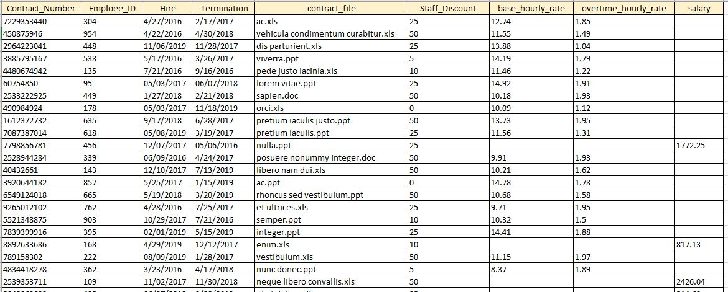

1NF

PK is contract_number.

Attributes base­_hourly_­rate, overtime_hourly_rate and salary can contains NULL values. They will be separate in new entities.

FK is employee_ID.

2NF

Entity is in 1NF and all attributes depend on PK.

3NF

Entity is in 3NF, there is no transitive dependencies.

Preview of table contracts after normalization:

